CATHERSTON STUD
FROZEN SEMEN BREEDING CONTRACT
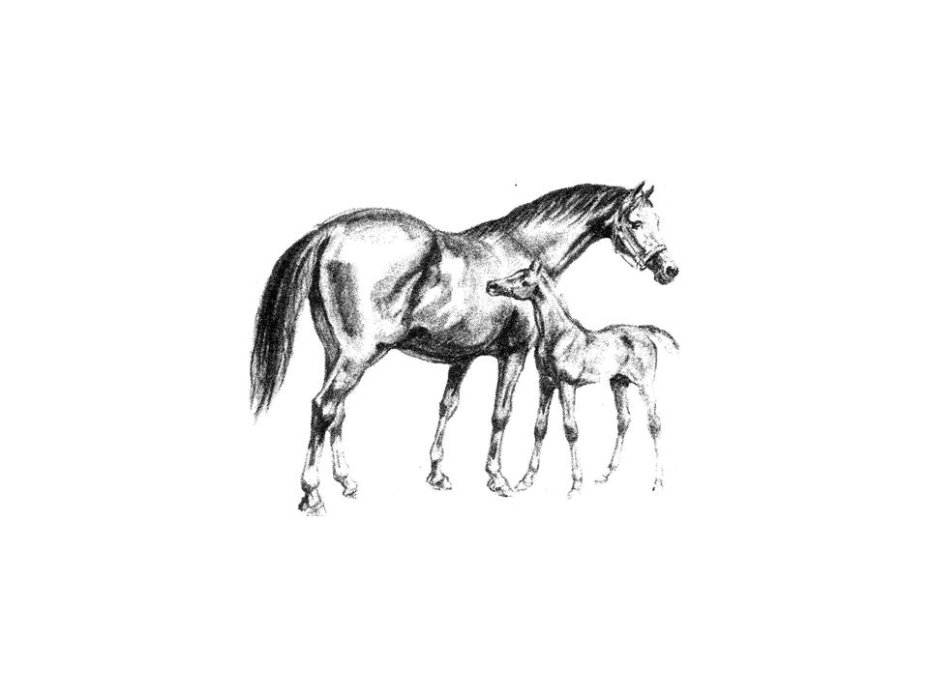

This Agreement is made by and between Catherston Stud and (hereinafter referred to as the “Mare Owner”) for the breeding of the Mare described in Schedule One to this Contract to the Stallion (hereinafter referred to as the “Stallion”). Breeding shall be carried out using Frozen Semen and this contract applies to the purchase of One Breeding during the 201…. breeding season.

TERMS AND CONDITIONS

This contract is non-transferable. In consideration of the mutual covenants contained herein and for valuable consideration, the parties agree as follows:

- The Mare Owner understands that an examination of breeding soundness must be performed on the Mare and results reported to Catherston Stud prior to breeding with Frozen Semen, such examination to be carried out by a licensed Veterinary Surgeon and include a uterine culture.
- The Mare Owner understands that the “Certificate of Insemination” and “Certificate of Pregnancy Diagnosis” must be returned to Catherston Stud in order to receive a Breeding/Covering Certificate for foal registration purposes.
- The Stud Fee (breeding fee) as detailed in Schedule One to this Contract is payable by the Mare Owner in advance for the purpose of no more than three(3) insemination doses to be used in the breeding of one (1) live foal.
- The Mare Owner is responsible for payment to the Storage Agent of all local transportation and flask hire fees.
- Should the mare not become pregnant with the first insemination, a further two doses may be sent out individually. Semen is transported one (1) dose at a time as once semen has left the Storage Agent it cannot be returned to them.
- There is no live foal guarantee.
- In the event that a viable pregnancy and / or live foal is not achieved, there shall be no refund of any fees to the Mare Owner.
- In the event that the Mare produces live twins, the Mare Owner shall pay to Catherston Stud an additional Stud Fee as set out in Schedule One to this Contract.

SHIPPING AND HANDLING

- The Frozen Semen shall be shipped in a liquid Nitrogen “Vapour Shipper” at the Mare Owner’s expense.
- WKS, on behalf of Catherston Stud, will ship the Frozen Semen in a viable condition from the UK to the Storage Agent.
- The Storage Agent shall be liable for storing, packing and shipping the Frozen Semen in a viable condition to the Mare Owner.
- Catherston Stud holds no responsibility for shipping errors, misrouting or mistreatment of the Vapour Shipper by the Storage Agent or the local shipping company.
- All transportation and insurance costs for the Frozen Semen and Vapour Shipper shall be the responsibility of the Mare Owner.
- The Mare Owner is responsible for payment to the Storage Agent of all transportation and Vapour Shipper hire fees prior to shipment of the Frozen Semen. No semen shall be shipped until all fees have been paid. The Storage Agent’s standard terms and charges are available upon request.
- The Vapour Shipper shall be sealed with a plastic tie wrap. On arrival of the Vapour Shipper, it is the Mare Owner’s responsibility to ensure that this tie wrap has not been broken and that the container is frosty when first opened to transfer the Frozen Semen out of the Vapour Shipper. If the shipment did not arrive sealed and cold, the Mare Owner must file a report of damaged shipment with the Storage Agent and courier company within 24 hours of shipment receipt. It is the responsibility of the Mare Owner to file this report with the Storage Agent and courier company. Catherston Stud and the Storage Agent are not responsible for damage howsoever caused to the Frozen Semen once it has left the Storage Agent’s premises.
- The use and management of the Frozen Semen is the sole responsibility of the Mare Owner and his/her Veterinary Surgeon. It is the responsibility of the Mare Owner to procure liquid nitrogen storage (short term or long term) of the Frozen Semen. The Frozen Semen must be transferred immediately from the Vapour Shipper into a viable liquid nitrogen Storage Tank and the Vapour Shipper returned to the Storage Agent.
- The Mare Owner understands that failure to transfer the Frozen Semen within 24 hours of receipt may jeopardise the viability and quality of the Frozen Semen and shall void this Contract. The Mare Owner further understands that the Frozen Semen must be transferred very quickly from the Vapour Shipper to the Storage Tank.
- Catherston Stud assumes no responsibility for any loss or damage incurred to the Mare. The Mare Owner assumes all responsibility for the condition of the Mare and shall bear all risk of loss or damage to the Mare whether by death, disease, injury, infection or other cause. The Mare Owner further agrees to indemnify and hold harmless the Stallion Owner for any and all damages and /or liability.
- This Contract follows the Mare as detailed above and in Schedule One to this Contract and may not be transferred to another Mare or Mare Owner without the prior written agreement of Catherston Stud.

Stud (Breeding) Fees for 2015 / 2016 Breeding Season
Timolin BWBS / SHB(GB) £1,100 Catherston Dazzler SHB(GB) £900
Catherston Springsteen SHB(GB) £600 Littledale Bright Star – Pony £350

USA Agent Mrs Christine Miller, Ocala Equine Medical Centre
emcostallionservices@yahoo.com
New Zealand Agents: Dr Lee Morris BVSc, DVSc, Dipl ACT ,
info@equibreed.co.nz
Australian Agents: Craig Mayne, GeneMovers
info@genemovers.com.au
The Mare Owner and Catherston Stud agree that the terms and conditions set out in this Contract shall form the entire Contract between the Parties.

This Contract shall be interpreted and governed by the laws of the United Kingdom. Any dispute under this Contract shall be subject to arbitration via the International Court of Arbitration.

Signed For and on behalf of

Stallion Owner: Date:

Full Name:

Address:

Signed For and on behalf of

The Mare Owner: Date:

Full Name:

Address:

Catherston Stud Supplementary Information

Contact Details Croft Farm, Over Wallop, Stockbridge, Hampshire SO20 8HX, UK
Stud Manager: Mrs Anne Dicker
Telephone: +44 (0)1264 782716
Mobile No: +44 (0)7771 823985
Fax: +44 (0) 1264 782717
Email: catherston@btconnect.com

Bank Details
Account Name: Catherston Stud
Bank Name: Barclays Bank
Bank Location: 5 High Street, Andover, Hampshire SP10 1LN
Sort Code: 20-02-25
Account No: 73450236
IBAN: GB59 BARC 2002 2573 4520 36
Swift/BIC: BARCGB22

SCHEDULE ONE

TO THE FROZEN SEMEN BREEDING CONTRACT

BREEDING SEASON / HEMISPHERE:
REGISTERED NAME OF STALLION:
BREEDING / STUD FEE: (Clause 3) GBP (pounds Sterling)
NUMBER OF INSENIMATION
DOSES PER CONTRACT (Clause 3): Three (3) insemination doses
ADDITIONAL STUD FEE: (Clause 7): GBP (Pounds Sterling)

MARE OWNER VET / AI TECHNICIAN

Name Name

Address Practice

Address

Telephone Telephone

Mobile Mobile

Fax Fax

Email Email

MARE DETAILS

Registered Name Stable Name

Breed Colour Height

Age ULEN Number

A scanned copy of the mares’ passport must accompany this form including the breeding pages, identification page, name and ULEN number & any grading certificate.

BREEDING HISTORY

Years Live foal / Stallion used Has the mare previously had:
Covered Barren / Aborted
a) Uterine infections Y / N
b) Her vulva stitched Y / N
c) Retained placenta Y / N
d) Genital tract damage Y / N
e) Infertility treatment Y / N
If yes, please provide details

