CATHERSTON STUD
NOMINATION AGREEMENT FOR CHILLED SEMEN
ARTIFICIAL INSEMINATION OF MARES
Terms and Conditions of Acceptance
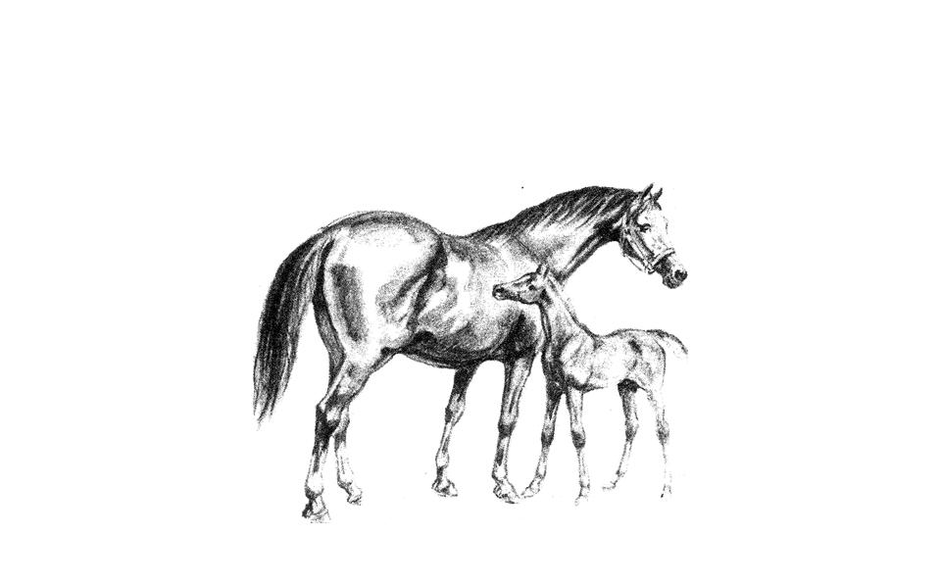

Our aim at Catherston Stud is to breed top class stock – mares with poor confirmation or known hereditary diseases will not be accepted. The Stud reserves the right to refuse any mare for Artificial Insemination.

Swabs
In accordance with the recommendations of the HBLB we require all mares are tested for EVA prior to mating or insemination. We would also suggest that you discuss with your veterinary surgeon whether a CEM swab is required. All mares coming to the stud will require a CEM swab, EIA and EVA blood tests after 1st January 2016.

Notification
Full co-operation between the mare owner, Catherston Stud and the veterinary surgeon carrying out the insemination is essential. It is important that Catherston Stud is kept informed of the mare’s progress and informed as soon as the mare comes into season during the months prior to insemination. The attending veterinary surgeon should contact Catherston Stud to request semen. Morning notification for the following day’s delivery is extremely important and should this fall over a weekend, Monday or Bank Holiday, early notification is always helpful and can make a large difference to the transport costs. It should be remembered that the Catherston Stallions also compete and therefore any advance warning that you can give will help ensure that we are able to supply semen when it is required.

Transport of semen
The chilled semen will be transported in an “equitainer” which will be sent by Royal Mail Special Delivery or by courier. It should be noted that there is only limited transport by these companies on Saturday, Sunday and Mondays, so a special service may have to be arranged, or the deliveries made one day early. The normal delivery time is 9.00am but a later delivery time can be arranged. We will make every attempt to deliver as requested. Due to the many variables associated with this we cannot, under any circumstances, make promises of delivery date or time, or even promises of availability continually throughout the season.
Once the semen is in the hands of the courier it is the property of the mare owner.

Fees
The Stud Fee is payable in full prior to the delivery of the semen, along with the Grooms Fee. Charges for packing and shipping of semen are payable at the point of ordering. Semen will not be despatched without prior payment. We accept Bank Transfers, Cheques and Debit Cards. Credit Cards will incur a 7.5% charge on the total amount prior to payment. Our Bank details are as follows: Catherston Stud Sort Code 20-02-25 Account Number: 73450236 IBAN GB59 BARC 2002 2573 4502 36 Please use your surname & the mares name as the reference.

Equitainers
Under normal circumstances a polystyrene equitainer will be used. This is preferable as it is more hygienic and incurs less carriage costs. However there may be times where it is more appropriate to use the old style “Equitainer Bucket”. The mare owner is responsible for the safe return of either Equitainer and any parts that are missing or damaged will be charged accordingly.

Polystyrene Equitainer hire including consumables £25 per delivery (inc VAT)
Royal Mail Special Delivery (Tuesday – Saturday) £30 per delivery (inc VAT)
Other carriage / courier services by arrangement.

Cancellation Fee
25% of the Stud fee will be charged for any nomination not taken up, unless a veterinary certificate is produced stating a valid reason for the mares not being inseminated.

Pregnancy Diagnosis
We recommend that all mares are examined by a veterinary surgeon between 16 – 20 days after insemination to confirm pregnancy and to spot possible twinning. Mares should then be scanned again at 28 days to confirm a heartbeat and should twins have been missed there is an opportunity to remedy the situation. (It is advisable to scan again at between 42 – 60 days to confirm pregnancy) A further pregnancy confirmation should be performed in the last week of September and Catherston Stud notified of the result.

Covering Certificates
All certificates will be forwarded to the mare owner on receipt of a Positive Pregnancy Diagnosis certificate after the 1st October.

No Foal 1st October 20% Fee – Chilled semen only
If an artificially inseminated mare is certified not in foal by 1st October the stud fee will be returned less 20% which will be retained by Catherston Stud. If a covering certificate has been issued then the stud fee will only be returned to the mare owner on receipt of the covering certificate.

Embryo Transfer
Specific contracts may be drawn up for embryo transfer and details should be discussed directly with Mrs Loriston-Clarke or Mrs Dicker. Full information of the donor mare and the attending veterinary surgeon and recipient mares must be disclosed in the first instance.

Mares in foreign countries
Frozen semen can be exported from certain stallions. We have agents in USA, Australia and New Zealand and contact details can be obtained from Catherston Stud. For other countries, full details need to be forwarded to Catherston Stud who will arrange for West Kington Stallion Centre to deal with further arrangements.

USA Agent Mrs Christine Miller, Ocala Equine Medical Centre
emcostallionservices@yahoo.com
New Zealand Agents: Dr Lee Morris BVSc, DVSc, Dipl ACT ,
info@equibreed.co.nz
Australian Agents: Craig Mayne, GeneMovers
info@genemovers.com.au

Mr A G Loriston-Clarke, Mrs A J F Loriston-Clarke & Mrs A F Dicker
Croft Farm, Over Wallop, Stockbridge, Hampshire SO20 8HX
Tel 0 (44) 1264 782716 Fax 0 (44) 1264 782717
e-mail: catherston@btconnect.com Web-site: www.cathestonstud.com

CATHERSTON STUD

NOMINATION AGREEMENT FOR ARTIFICIAL INSEMINATION OF CHILLED SEMEN

I agree to take a Nomination to the Stallion

_________________________________________ for the season 20____, at £ ________ Stud Fee plus £30.00 Grooms Fee. (inc VAT) for the Mare listed below.
MARE DETAILS
Registered Name Stable Name

Breed Colour Height Age
ULEN No Registration No

A scanned copy of the mares’ passport must accompany this form including the breeding pages, identification page, name and ULEN number & any grading certificate and any competition or progeny results.
BREEDING HISTORY
Years Live foal / Stallion used Has the mare previously had:
Covered Barren / Aborted a) Uterine infections Y / N
b) Her vulva stitched Y / N
c) Retained placenta Y / N
d) Genital tract damage Y / N
e) Infertility treatment Y / N
If yes, please provide details

VETERINARY SURGEON DELIVERY ADDRESS

Name

Practice

Address

Post Code Post Code
Telephone Mobile
Email

MARE OWNER

Name

Address

Post Code

Telephone Mobile

Email

I have read and agree to the Terms and Conditions offered by Catherston Stud in relation to Artificial Insemination for Chilled Semen.

Signature Date

